Performance Optimization and JavaScript Best Practices in xforms
!important: - used unused references
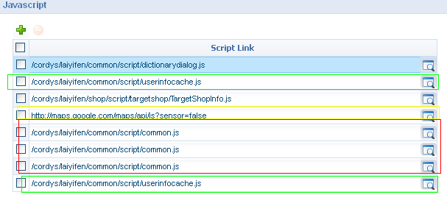
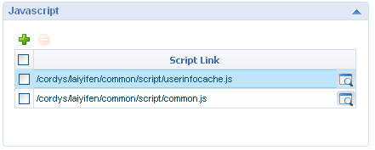

- Don’t Change a Variable’s Type After Initial Declaration.
- Don’t Use Global Variables or minimize the usage and garbage collect it properly after usage.
- Use the switch Statement to Handle Multiple Conditions.
Ex:
BAD  if(name=="a"){}  else if (name=="b"){}  else if(name=="c"){}  else if(name=="d"){}  else if(name=="e"){} | GOOD  switch(name)  {  case "a":  break;  case "b":  breask;  case "c":  breask;....  }
Note: There wont be any performance difference but good for maintenance and executing default conditions
- Use try-catch to Prevent Errors from Displaying to the User.
- Make Multi-Line Comments Readable, But reduce size of comments as much as possible remove the unnecessary comments in will increase the file size hence the loading time.
- Minimize the iterations/number of comparisons (loops).
- Declare variables outside the loops always
BAD  for(var i=0;i<array.length;i++)  {  var container = document.getElementById("container");  container.innerHTML + = "number"+i  } | GOOD  var container = document.getElementById("container");  for(var i=0;i<array.length;i++)  {  container.innerHTML + = "number"+i  }
Note :
- Reuse code (reusable code can be converted as generic methods) and optimize the method calls.
If(){
GetApprovalModel.clear();
GetApprovalModel.putData(approvalDataNode);
GetApprovalModel.refreshAllViews();
}
else{
GetApprovalHistoryModel.clear();
GetApprovalHistoryModel.putData(approvalHistoryDataNode);
GetApprovalHistoryModel.refreshAllViews();
}
If(){
binddataToModel(GetApprovalModel,approvalDataNode);
}
else{
binddataToModel(GetApprovalHistoryModel,approvalHistoryDataNode)
}
function bindDataToModel(model,data)
{
model.clear();
model.putData(data);
model.refreshAllViews();
}

- use InnerHTML instead of creating multiple dom elements and appending it.
req:<div id='container'><div id= 'parent' class='parent'><div id= 'child' class='child'></div></div></div>
BAD  var parent = document.createElement("div");  parent.id="parent"  parent.className = "parent";  var child = document.createElement("div");  child.id="child"  child.className = "child";  parent.appendChild(child);  document.getElementById("container").appendChild(aprent); | GOOD document.getElementById("container").innerHTML="<div id= 'parent' class='parent'><div id= 'child' class='child'></div></div>";

- Avoid unnecessary DOM references in objects.
- Maximize object resolution speed and minimize scope chain.
var url = location.href;
var url = window.location.href;

- Caching values to variables
Example:
Bad:
var childOldNode = cordys.selectXMLNode(oldNode,".//*[local-name()='" + model.instance.businessObjectName + "']");
var childNewNode = cordys.selectXMLNode(newNode,".//*[local-name()='" + model.instance.businessObjectName + "']");

Good:
var bObj = model.instance.businessObjectName;
var childOldNode = cordys.selectXMLNode(oldNode,".//*[local-name()='" + bObj + "']");
var childNewNode = cordys.selectXMLNode(newNode,".//*[local-name()='" + bObj + "']");

